Date of publication xxxx 00, 0000, date of current version xxxx 00, 0000.
Digital Object Identifier 10.1109/ACCESS.2024.Doi Number
Quantum Machine Learning for Radio Link Quality Classification and Throughput Prediction in a 5G Standalone Testbed: A Comparative and Scalability Study
A. MUKHANBET¹, Y. NURAKHOV¹, T. IMANKULOV¹, B. DARIBAYEV², AND PAULO TRIGO³
¹Farabi University, Almaty, Kazakhstan
²Shakarim University, Semey, Kazakhstan
³Instituto Superior de Engenharia de Lisboa (ISEL), Lisboa, Portugal
Corresponding author: A. Mukhanbet (e-mail: mukhanbetaksultan0414@gmail.com).
This research was funded by the Committee of Science of the Ministry of Science and Higher Education of the Republic of Kazakhstan (Grant No. BR24993211).
ABSTRACT Quantum machine learning is a candidate technology for data-driven radio access network intelligence, yet evidence of its behavior on real network telemetry is scarce. This article presents a systematic benchmark of quantum learning models on 10 000 per-user scheduler reports collected from an operational fifth-generation standalone testbed built with the srsRAN radio access stack and the Open5GS core network. On a balanced link-quality classification task and a downlink-throughput regression task, seven quantum models are evaluated: a quantum-kernel support vector machine, a fidelity-based quantum nearest-neighbor classifier, a variational quantum neural network, a single-qubit data re-uploading classifier, a hybrid quantum-classical network, a quantum convolutional neural network, and a boosting ensemble selected by quadratic unconstrained binary optimization. They are compared with a quantum-kernel support vector regressor, a quantum clustering procedure, and five classical baselines under one leakage-free protocol. The quantum classifiers reach accuracy parity with the baselines (0.84-0.85 versus 0.84-0.86) while attaining the three highest areas under the receiver operating characteristic curve of the study, up to 0.899. Scalability experiments that grow the variational network from two to nine qubits show linear growth of trainable parameters and compiled gates, a 4.6-fold increase in training time, and accuracy that peaks at the intrinsic dimensionality of the data. Complementary sweeps quantify kernel concentration, depth-dependent trainability, robustness to depolarizing noise up to probability 0.15, and a measurement budget of 128 shots.
INDEX TERMS 5G mobile communication, machine learning, quantum computing, quantum machine learning, quantum neural networks, radio access networks, support vector machines, telemetry, variational quantum circuits.
I. INTRODUCTION
Fifth-generation (5G) and forthcoming sixth-generation (6G) mobile networks are increasingly conceived as data-driven systems in which radio-resource management, link adaptation, admission control, and network slicing are steered by machine-learning (ML) models operating on continuous streams of key performance indicators (KPIs) [1], [2]. The Open Radio Access Network (O-RAN) architecture institutionalizes this trend by embedding RAN Intelligent Controllers (RICs) whose xApps and rApps host learned policies acting on exposed RAN telemetry [3], [4]. Three constraints delineate the regime in which such a model must operate. First, small samples: models are retrained per cell, per slice, or per time-of-day window on hundreds to a few thousands of fresh KPI records, so that the learned policy tracks the current radio environment. Second, low feature dimensionality with strong physical correlation: a scheduler report carries on the order of ten KPIs, several of which are coupled through the link-adaptation loop. Third, recurring retraining cost: because retraining is frequent and per-cell, the computational price of fitting a model matters as much as its terminal accuracy. Any candidate model family for RAN intelligence must be evaluated under exactly these conditions, which is the evaluation regime adopted throughout this article.
In parallel, quantum computing has crossed from theory into publicly accessible hardware [5]-[7], and quantum machine learning (QML) [8] asks whether encoding data into the exponentially large Hilbert space of a quantum register yields learning models with useful inductive biases. The common substrate of all QML algorithms is the quantum data encoding: a classical feature vector $x∈ℝ^{n}$ is mapped, by a parameter-free circuit $U_{ϕ}\left(x\right)$ of single-qubit rotations and entangling gates, to a quantum state $\left|ϕ\left(x\right)⟩=U_{ϕ}\left(x\right)\right|0⟩^{⊗n}$ living in a $2^{n}$-dimensional complex vector space. Because the rotation angles enter through trigonometric functions and the entangling gates correlate the qubits, the map is highly nonlinear in $x$; the choice of encoding determines the entire function class that the model can express [9], [10]. What distinguishes the QML algorithm families is what happens after the encoding, and Fig. 3 summarizes the four architectures benchmarked in this study.
The quantum kernel family (Fig. 3(a)) [11]-[13] never trains a quantum parameter at all. For every pair of samples the processor executes the circuit $U_{ϕ}^{†}\left(x_{2}\right)U_{ϕ}\left(x_{1}\right)$ and measures the probability of the all-zeros outcome, which equals the state fidelity $k\left(x_{1},x_{2}\right)=\left|⟨ϕ\left(x_{1}\right)\right|ϕ\left(x_{2}\right)⟩|^{2}$, a positive-semidefinite kernel by construction. The resulting Gram matrix is handed to a classical convex solver: a soft-margin support vector machine (SVM) yields the QSVM classifier, an $ε$-insensitive regressor yields QSVR, and a majority vote over the smallest fidelity distances $1−k$ yields the QKNN classifier; a single Gram construction therefore amortizes over three models. The variational family (Fig. 3(b)) [14]-[17], by contrast, places a trainable ansatz $W\left(θ\right)$ of parameterized rotations and entanglers after the encoding and measures the expectation of a Pauli observable, e.g., $f_{θ}\left(x\right)=⟨Z_{0}⟩$. The circuit is the model: a classical optimizer (Adam in this work) minimizes a loss over the training set, obtaining exact gradients of the quantum expectation through the parameter-shift rule [15], and the hybrid quantum-classical loop iterates until convergence. Architectural variants adjust what sits between encoding and measurement: the data re-uploading classifier of Perez-Salinas et al. [18] interleaves encoding and trainable rotations on a single qubit, which is provably a universal approximator; a hybrid quantum-classical network wraps the quantum layer between classical dense layers trained jointly; and the quantum convolutional neural network (QCNN, Fig. 3(c)) [19] alternates trainable two-qubit convolution blocks on neighboring qubits with pooling blocks that merge a source qubit into a sink by controlled rotations and discard it, shrinking the register $4→2→1$ in our implementation, a structure that is provably resistant to vanishing gradients. Finally, the annealing family (Fig. 3(d)) [20]-[22] reformulates learning as discrete optimization: QBoost encodes the selection of weak classifiers into a quadratic unconstrained binary optimization (QUBO) problem whose ground state is sought by a quantum annealer or, equivalently, a simulated-annealing sampler; the quantum cost is a single anneal, independent of the dataset size, after which the selected ensemble is a purely classical object.
Theory suggests that the small-sample, low-dimensional RAN regime is precisely where these models deserve examination: quantum models enjoy provable generalization guarantees from few training data [23], can possess higher effective dimension than comparable classical networks [24], and their kernel variants provably help when the data carry structure that the quantum feature map captures and classical kernels do not [25]. Headline accuracy alone, however, does not establish practical viability. On noisy intermediate-scale quantum (NISQ) hardware every added qubit and gate costs fidelity and runtime, and two negative results, barren plateaus, in which gradients of deep random circuits vanish exponentially in system size [26]-[28], and exponential kernel concentration, in which fidelities between generic encoded states collapse towards a constant as qubits are added [29], predict that larger is not better for NISQ models. A credible assessment must therefore quantify how trainable parameters, compiled gate counts, circuit depth, training time, and accuracy co-evolve as the circuit is scaled, and must bound the noise and measurement budgets under which the trained models survive. Such a joint characterization on real network telemetry is, to our knowledge, absent from the literature: existing QML evaluations in the networking domain rely on simulated channels or public non-network datasets, and typically compare one quantum model against one classical baseline.
This article develops, validates, and characterizes a complete QML pipeline on KPI telemetry collected from an operational 5G standalone (SA) testbed built with the srsRAN gNodeB and the Open5GS core. We address four research questions.
RQ1: What discrimination can quantum classifiers attain on a balanced link-quality task built from real 5G scheduler telemetry, and how does it compare with tuned classical baselines under an identical small-sample protocol (300 training and 100 test records)?
RQ2: Which quantum model family, kernel-based, variational, convolutional, or annealing-based, offers the best accuracy-cost profile, and does the quantum kernel transfer without retraining to the downlink-throughput regression task?
RQ3: How do trainable parameters, compiled elementary gates, circuit depth, and training/inference time co-evolve with test accuracy as the variational circuit is scaled from 2 to 9 qubits?
RQ4: Is the workload NISQ-feasible, that is, up to what depolarizing noise probability and down to what measurement-shot budget do the trained models retain their accuracy?
The contributions are deliberately framed as a systematic experimental study rather than a methodological innovation: each individual model (QSVM, QNN, QCNN, QBoost, and others) is established, but their side-by-side composition on real RAN telemetry, under one leakage-free protocol and with a joint scalability and feasibility analysis, is not. The contributions are as follows.
C1: A reproducible QML benchmark on real 5G telemetry: a complete pipeline that ingests raw srsRAN scheduler metrics (including malformed console artifacts), constructs leakage-free classification and regression tasks, and evaluates twelve models under identical conditions (Section III).
C2: A broad quantum suite, comprising QSVM, QKNN, QNN, single-qubit data re-uploading, a hybrid quantum-classical network, QCNN, and QBoost, benchmarked side by side with QSVR for regression, quantum $k$-means for unsupervised structure, and five classical baselines.
C3: Empirical evidence of ranking-quality advantage at accuracy parity: the three best values of the area under the receiver operating characteristic curve (ROC-AUC) of the study belong to quantum models (QCNN 0.8990; QNN and hybrid 0.8986), while accuracy is statistically indistinguishable from the classical baselines (Section IV).
C4: A quantitative circuit-scalability law for the QNN: growing the register from 2 to 9 qubits multiplies trainable parameters by 4.4 and compiled gates by 4.8 and increases training time 4.6-fold, while accuracy peaks at the register width matching the intrinsic data dimensionality and degrades beyond it.
C5: A NISQ-feasibility characterization: the trained QNN retains full accuracy under per-qubit depolarizing noise up to $p=0.15$ and requires only 128 measurement shots to match analytic accuracy.
The remainder of this article is organized as follows. Section II reviews related work. Section III presents the experimental architecture, testbed, quantum models, and evaluation protocol. Section IV reports the results. Section V outlines the deployment pathway into the RAN. Section VI answers the research questions, analyzes the findings, and states limitations and future work, and Section VII concludes.
II. RELATED WORK
A. MACHINE LEARNING FOR MOBILE NETWORKS
The application of ML across the mobile-network protocol stack is extensively documented. Zhang et al. [1] surveyed deep learning in mobile and wireless networking across more than five hundred studies, covering traffic prediction, resource allocation, and mobility management; Sun et al. [2] complemented this with a technique-oriented survey identifying small-sample regimes and model-retraining cost as open issues for wireless ML. At the architectural level, Polese et al. [3] provided the reference tutorial on O-RAN, detailing how the near-real-time and non-real-time RICs expose RAN telemetry to learned control, while Bonati et al. [4] demonstrated end-to-end data-driven control loops on programmable testbeds. The classical algorithms dominating this literature trace back to the support vector machine of Cortes and Vapnik [30], the nearest-neighbor rule of Cover and Hart [31], and the random forest of Breiman [32]; these, together with multilayer perceptrons and logistic regression, constitute the baseline suite of this study, implemented in scikit-learn [33]. On the infrastructure side, Gomez-Miguelez et al. [34] introduced the srsLTE/srsRAN open-source radio stack used here; the Open5GS project [35] provides the standards-compliant 5G core; and the physical-layer procedures governing the collected KPIs are specified in 3GPP TS 38.214 [36].
B. FOUNDATIONS OF QUANTUM MACHINE LEARNING
The QML program was catalyzed by fault-tolerant-era algorithms: Rebentrost et al. [11] formulated a quantum support vector machine with exponential speed-up for kernel evaluation, and Lloyd et al. [37] proposed quantum algorithms for supervised and unsupervised learning, including the quantum $k$-means primitive adapted in this work. Biamonte et al. [8] consolidated the field in a widely cited perspective. The hardware context was set by Preskill [5], who coined the NISQ term; by Arute et al. [6], who reported the first beyond-classical computation on a 53-qubit processor; and by Kim et al. [7], who demonstrated utility-scale error-mitigated computation on 127 qubits. Bharti et al. [38] reviewed the resulting NISQ algorithm landscape.
C. NISQ LEARNING MODELS: KERNEL, VARIATIONAL, AND ANNEALING FAMILIES
NISQ-compatible learning models divide into families that this article benchmarks side by side. In the kernel family, Havlicek et al. [12] demonstrated supervised learning with quantum-enhanced feature spaces on superconducting hardware; Schuld and Killoran [13] established the formal correspondence between quantum encodings and reproducing-kernel Hilbert spaces, later systematized in [39]; and Huang et al. [25] derived the data-dependent conditions under which quantum kernels can outperform classical ones. In the variational family, Peruzzo et al. [14] introduced the hybrid variational loop; Mitarai et al. [15] derived the parameter-shift rule that makes circuit training hardware-compatible; Schuld et al. [16] and Farhi and Neven [40] proposed circuit-centric classifiers; Benedetti et al. [41] reviewed parameterized quantum circuits as ML models; and Cerezo et al. [17] unified the paradigm. Architectural variants adopted in this study include the single-qubit data re-uploading classifier of Perez-Salinas et al. [18], proven to be a universal approximator, and the quantum convolutional neural network of Cong et al. [19], whose pooling structure is provably resistant to barren plateaus. In the annealing family, Neven et al. [20] cast ensemble selection as a QUBO problem (QBoost); Willsch et al. [21] trained kernel SVMs on a physical D-Wave annealer; and Mott et al. [22] applied annealing-based learning to Higgs-boson classification, establishing the methodology adopted for our QBoost implementation.
D. TRAINABILITY AND EXPRESSIVITY LIMITS
Theoretical characterizations inform our experimental design directly. Sim et al. [42] quantified ansatz expressibility and entangling capability; Schuld et al. [9] showed that data-encoding strategies determine the Fourier expressivity of variational models, motivating the repeated angle-encoding map used here; and LaRose and Coyle [10] analyzed the robustness of such encodings to noise. On the cautionary side, McClean et al. [26] identified barren plateaus in random deep circuits; Holmes et al. [27] connected them quantitatively to ansatz expressibility; Wang et al. [28] showed that hardware noise itself induces them; Caro et al. [23] proved generalization bounds from few training data; and Thanasilp et al. [29] proved exponential concentration of fidelity kernels, which our qubit-sweep experiment observes empirically on real telemetry.
E. QUANTUM METHODS FOR COMMUNICATION NETWORKS
Nawaz et al. [43] surveyed prospective roles of quantum computing and QML in 6G, identifying resource allocation and channel estimation as candidate workloads, and Cacciapuoti et al. [44] analyzed the networking challenges of the emerging quantum internet. Published experimental QML work in the networking domain, however, has largely relied on simulated channels or public non-network datasets, has typically compared a single quantum model against a single classical baseline, and has not reported resource-accuracy scaling. The present study addresses these gaps.
III. MATERIALS AND METHODS
A. STUDY DESIGN
This investigation is a single-testbed experimental benchmark with internal validation. The protocol, comprising the KPI schema, target definitions, leakage controls, preprocessing chain, model roster, hyperparameters, and the analysis plan (comparative metrics, six scientific sweeps, and the circuit-scalability study), was fixed before model fitting, and all stochastic steps use a fixed random seed to guarantee reproducibility. The complete pipeline is released as a single executable notebook.
Fig. 1 presents the overall architecture of the experimental study. Stage I is the 5G SA testbed: user equipment attaches over the NR Uu interface to the srsRAN gNodeB, which connects over N2/N3 to the Open5GS core; the gNB scheduler emits 10 000 per-UE KPI reports that form the raw dataset. Stage II cleans the raw log, constructs leakage-free classification and regression targets, and encodes the features (standardization, principal component analysis, angle scaling) for the quantum register. Stage III trains the model suite, comprising three gate-based quantum families (kernel, variational, convolutional), an annealing-based ensemble, a quantum clustering procedure, and five classical baselines, all consuming the identical encoded data. Stage IV evaluates the models and performs the scientific sweeps and the circuit-scalability study. The individual components of each stage are detailed in the subsections that follow.
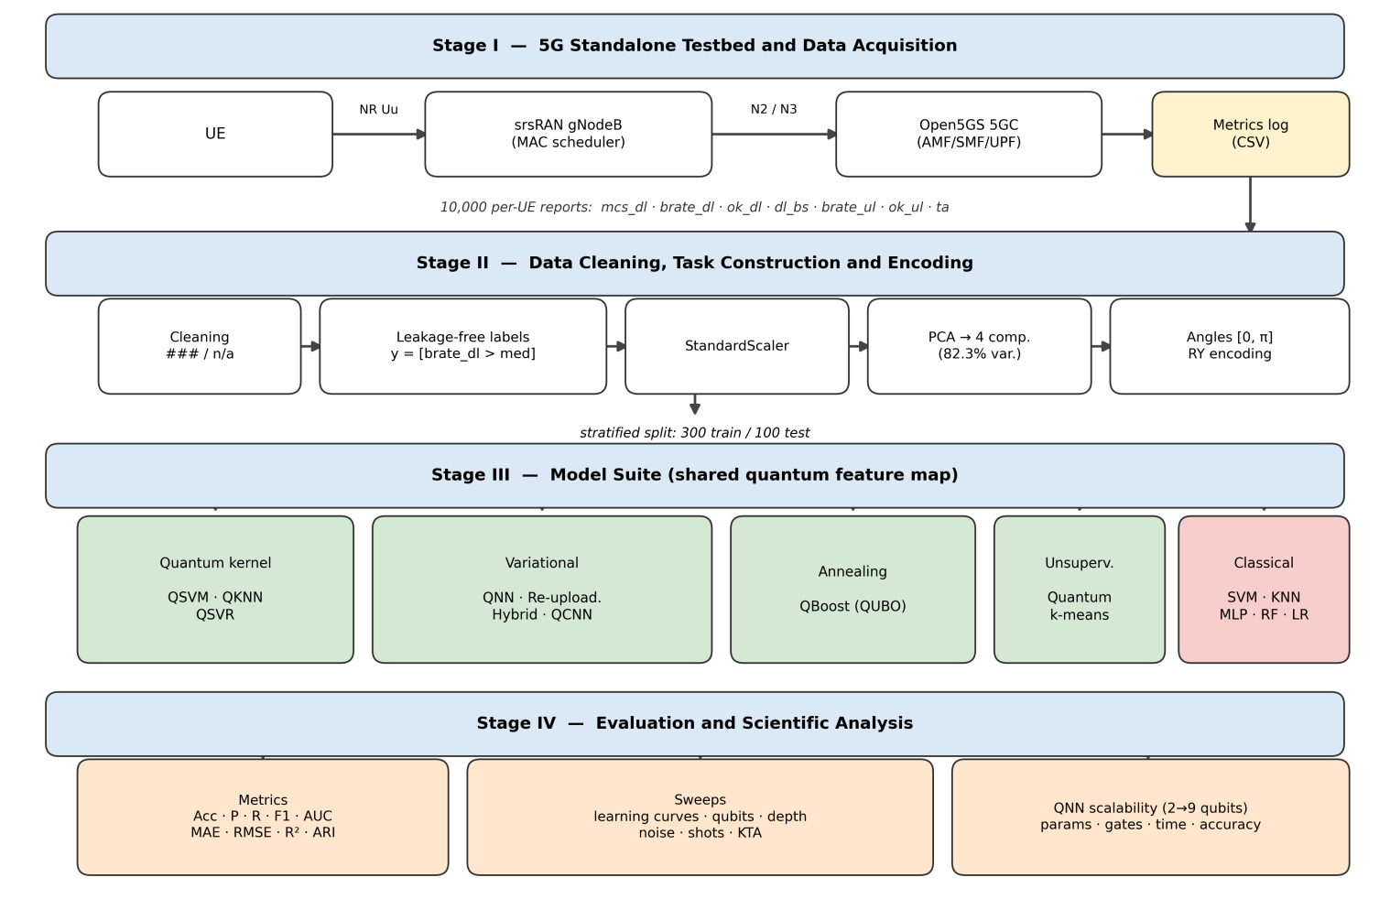
FIGURE 1. Overall architecture of the experimental study: (Stage I) 5G standalone testbed and KPI acquisition; (Stage II) data cleaning, task construction, and quantum encoding; (Stage III) quantum and classical model suite sharing one feature map; (Stage IV) evaluation, scientific sweeps, and the QNN circuit-scalability study.
B. 5G STANDALONE TESTBED AND DATASET
1) TESTBED ARCHITECTURE
The experimental network follows the 3GPP 5G SA architecture. The radio access segment is provided by the srsRAN project, an open-source, 3GPP-compliant software gNodeB descended from the srsLTE suite [34], and the core network functions (AMF, SMF, UPF, NRF, UDM, AUSF, PCF) are provided by Open5GS [35]. User equipment attaches to the gNB over the NR Uu interface; the gNB connects to the core over N2 (NGAP) and N3 (GTP-U). During operation the srsRAN scheduler emits periodic per-UE metric reports; these reports constitute the raw material of this study.
2) COLLECTED KPIs
Each record of the dataset corresponds to one scheduler reporting interval for one connected UE and contains the fields listed in Table I. The downlink modulation-and-coding-scheme index (mcs_dl) is the outcome of the gNB link-adaptation loop and is specified by 3GPP TS 38.214 [36]; the observed range 26 to 28 corresponds to the highest spectral-efficiency entries of the MCS table and indicates operation in good channel conditions. The bitrate fields (brate_dl, brate_ul) report the scheduled downlink and uplink throughput in the units emitted by the srsRAN metrics interface; ok_dl and ok_ul count successfully acknowledged transport blocks; dl_bs reports the downlink buffer status; and ta is the timing-advance command tracking the UE-gNB propagation delay.
TABLE I
Fields of the srsRAN Per-UE Scheduler Report Used in This Study and Their Descriptive Statistics Over the 10 000 Collected Records
Field | Description | Mean | Std. | Min | Max
mcs_dl | DL modulation and coding scheme | 26.9 | 0.8 | 26 | 28
brate_dl | DL scheduled bitrate | 2964.3 | 1719.0 | 824.2 | 6338.2
ok_dl | DL acknowledged transport blocks | 2.16 | 1.20 | 1 | 4
dl_bs | DL buffer status | 42.81 | 0.08 | 42.7 | 42.9
brate_ul | UL scheduled bitrate | 47698.4 | 18575.3 | 9558.0 | 84176.1
ok_ul | UL acknowledged transport blocks | 12.43 | 4.71 | 3 | 20
ta | Timing advance | 520.9 | 0.83 | 520 | 522

3) DATA CLEANING
Raw srsRAN console metrics contain formatting artifacts that must be handled before learning: fixed-width columns overflow into ### placeholders, idle intervals produce n/a entries, and large bitrates may be abbreviated with k/M magnitude suffixes. The ingestion stage of our pipeline therefore (i) auto-detects the field separator, (ii) parses magnitude suffixes into numeric values, (iii) converts placeholders to missing values, and (iv) drops incomplete rows, duplicates, and zero-traffic intervals. Applied to the collected capture, the procedure retained all 10 000 records, indicating a clean acquisition.
4) EXPLORATORY ANALYSIS
Fig. 2 shows the marginal distributions of the collected KPIs and their Pearson correlation structure. The downlink bitrate is strongly bimodal, with a low-throughput mode around 1.2 to 1.5 units and a high-throughput mode above 5 units, which makes a median-threshold binary label both natural and perfectly balanced. The correlation matrix confirms the expected physical couplings (e.g., between mcs_dl, ok_dl, and brate_dl) and shows that no single feature trivially determines the label once brate_dl itself is excluded from the feature set.
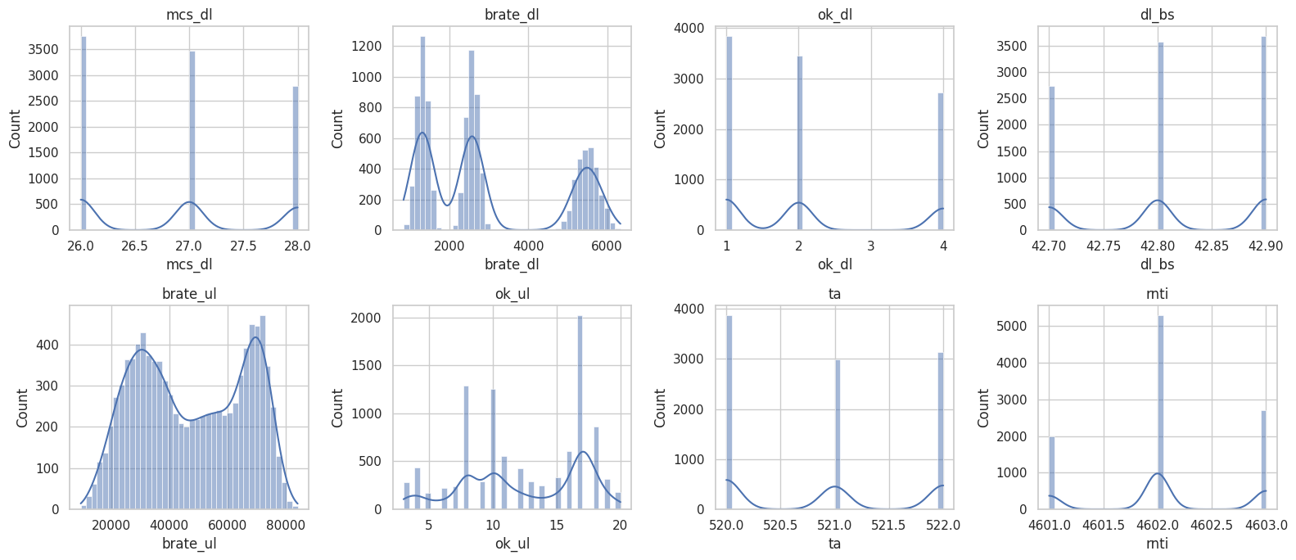
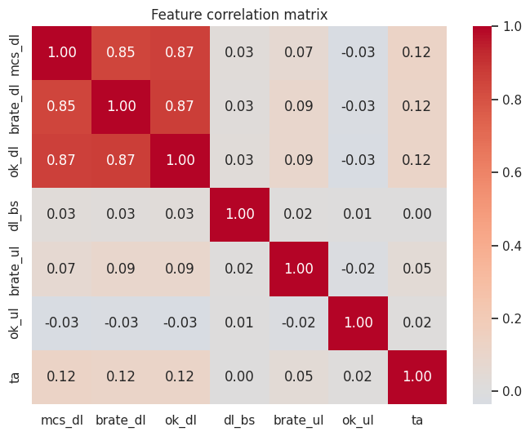
FIGURE 2. Exploratory analysis of the testbed dataset. Top: marginal distributions of the collected KPIs. Bottom: Pearson correlation matrix of the seven numeric KPI fields.
5) LEARNING TASKS
Two supervised tasks and one unsupervised task are defined on the cleaned data. For the binary link-quality classification task the label is $y=I\left[\text{brate_dl}>\text{median}\right]$ with the empirical median equal to 2524.4; the median split yields exactly 5000/5000 samples per class. To prevent label leakage, brate_dl is excluded from the feature vector, which then consists of the six remaining KPIs of Table I. For the downlink throughput regression task the continuous target is brate_dl itself, predicted from the same six-feature vector. For the unsupervised traffic structure task the six-feature vectors are clustered without labels; cluster assignments are subsequently compared with the held-out classification labels via the adjusted Rand index.
C. QUANTUM MACHINE LEARNING METHODS
Fig. 3 summarizes the four algorithm families implemented in this study; the subsections below specify each model as configured for the experiments.
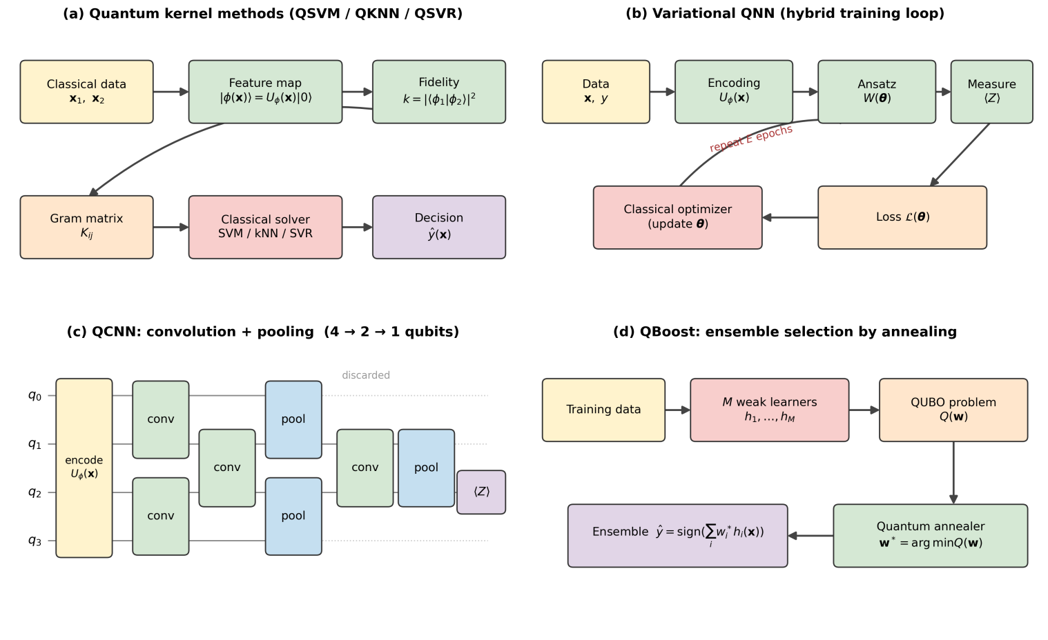
FIGURE 3. Architectures of the four QML algorithm families benchmarked in this study. (a) Quantum kernel methods: a parameter-free feature map produces states whose pairwise fidelity is measured on the quantum processor; the Gram matrix feeds a classical convex solver (QSVM/QSVR) or a nearest-neighbor vote (QKNN). (b) Variational QNN: a trainable ansatz follows the encoding, and a classical optimizer updates the gate parameters from measured expectations in a hybrid loop. (c) QCNN: alternating trainable convolution and pooling blocks reduce four qubits to one measured qubit. (d) QBoost: weak-learner selection is cast as a QUBO problem solved by (simulated) quantum annealing; inference is classical. Green blocks execute on the quantum processor; red blocks are classical computation.
1) QUANTUM DATA ENCODING AND FEATURE MAP
Let $x∈{\left[0,π\right]}^{n}$ denote a preprocessed feature vector (Section III-D) and let $n$ be the number of qubits. All models in this study share a common angle-encoding feature map $U_{ϕ}\left(x\right)$ consisting of two repetitions of a layer of single-qubit $R_{Y}$ rotations followed by a linear chain of CNOT entanglers, as in (1), and the encoded state is $\left|ϕ\left(x\right)⟩=U_{ϕ}\left(x\right)\right|0⟩^{⊗n}$.
$U_{ϕ}\left(x\right)=\prod_{r=1}^{2}{\left[\prod_{i=0}^{n−2}{{CNOT}_{i,i+1}}\prod_{i=0}^{n−1}{R_{Y}^{\left(i\right)}}\left(x_{i}\right)\right]}$ (1)
The repetition (data re-uploading at the encoding level) and the entangling chain make the map nonlinear in $x$ and prevent it from being classically trivial, while keeping the circuit shallow enough for NISQ execution. Fig. 4(a) shows the compiled fidelity-kernel circuit built from this map.
2) QUANTUM KERNEL AND QSVM
The fidelity kernel induced by the feature map is given by (2).
$k\left(x_{1},x_{2}\right)=\left|⟨ϕ\left(x_{1}\right)\right|ϕ\left(x_{2}\right)⟩|^{2}={\left|⟨0\left|​^{⊗n}U_{ϕ}^{†}\left(x_{2}\right)U_{ϕ}\left(x_{1}\right)\right|0⟩^{⊗n}\right|}^{2}$ (2)
This quantity is estimated by executing $U_{ϕ}^{†}\left(x_{2}\right)U_{ϕ}\left(x_{1}\right)$ and measuring the probability of the all-zeros outcome [12], [39]. The Gram matrix $K_{ij}=k\left(x_{i},x_{j}\right)$ over the training set is passed to a classical soft-margin SVM solver (regularization $C=1$), which finds the support-vector expansion in the quantum feature space. This hybrid division of labor, quantum kernel estimation and classical convex optimization, is the standard NISQ formulation of the QSVM.
3) FIDELITY-BASED QKNN
The same fidelity (2) defines a quantum distance $d\left(x_{1},x_{2}\right)=1−k\left(x_{1},x_{2}\right)$, operationally equivalent to a swap-test estimate of state overlap [37]. The QKNN classifier assigns to a test point the majority label of its $k=5$ training neighbors under $d$. Because the test-train fidelity matrix is a by-product of the QSVM evaluation, QKNN adds negligible quantum cost.
4) VARIATIONAL QUANTUM NEURAL NETWORK
The QNN applies the feature map (1) followed by a trainable ansatz $W\left(θ\right)$ composed of $L=4$ strongly-entangling layers, that is, per-qubit general rotations $R\left(α,β,γ\right)$ interleaved with cyclic CNOT entanglement [16], and measures the Pauli-$Z$ expectation of the first qubit, as in (3).
$f_{θ}\left(x\right)=⟨0\left|​^{⊗n}U_{ϕ}^{†}\left(x\right)W^{†}\left(θ\right)Z_{0}W\left(θ\right)U_{ϕ}\left(x\right)\right|0⟩^{⊗n}+b$ (3)
With labels mapped to $\{−1,+1\}$, the parameters $\left(θ,b\right)$ minimize the mean-squared error ℒ=1Ns​fθxs−ys2 by the Adam optimizer (learning rate 0.1, 60 epochs); gradients with respect to circuit parameters are obtained by automatic differentiation of the simulator, equivalent on hardware to the parameter-shift rule [15]. The class decision is $\hat{y}=I\left[f_{θ}\left(x\right)>0\right]$. Fig. 4(b) shows the compiled circuit.
5) SINGLE-QUBIT DATA RE-UPLOADING CLASSIFIER
Following Perez-Salinas et al. [18], a single qubit alternates $L=6$ times between data-loading rotations and trainable rotations, as expressed in (4).
$U\left(x,θ\right)=\prod_{l=1}^{L}{R}\left(θ_{l,2}\right)R\left({\tilde{x}}_{4:6}\right)R\left(θ_{l,1}\right)R\left({\tilde{x}}_{1:3}\right)$ (4)
Here $\tilde{x}$ is the feature vector zero-padded to six rotation angles and $R\left(⋅\right)$ denotes the general single-qubit rotation. The repeated interleaving of data and parameters makes the single qubit a universal function approximator; training follows the QNN protocol. The compiled circuit is shown in Fig. 4(c).
6) HYBRID QUANTUM-CLASSICAL NEURAL NETWORK
The hybrid model composes (i) a classical dense layer $z=\frac{π}{2}tanh\left(W_{1}x+b_{1}\right)+\frac{π}{2}$ mapping features to valid rotation angles, (ii) a quantum layer identical in structure to the QNN with $L=3$ entangling layers, and (iii) a classical affine read-out $a⟨Z_{0}⟩+b$. All parameters, classical weights and quantum gate angles alike, are optimized jointly by Adam, with gradients flowing through the quantum layer. The architecture represents the practically important design point in which a quantum circuit is embedded as one layer of an otherwise classical model.
7) QUANTUM CONVOLUTIONAL NEURAL NETWORK
The QCNN [19] alternates parameterized two-qubit convolution blocks on neighboring qubit pairs with pooling blocks that transfer information from a source qubit to a sink qubit via controlled rotations, halving the active register: $4→2→1$ qubits in our implementation, with the final measurement on the surviving qubit. The full network uses 18 trainable parameters and is shown in Fig. 4(d); training follows the QNN protocol.
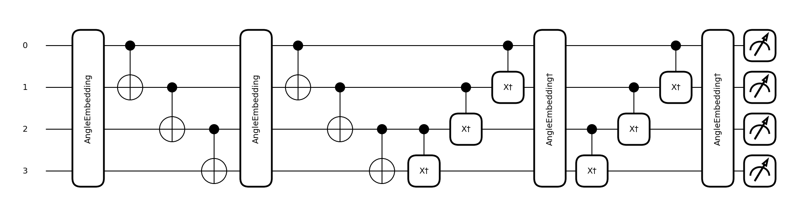
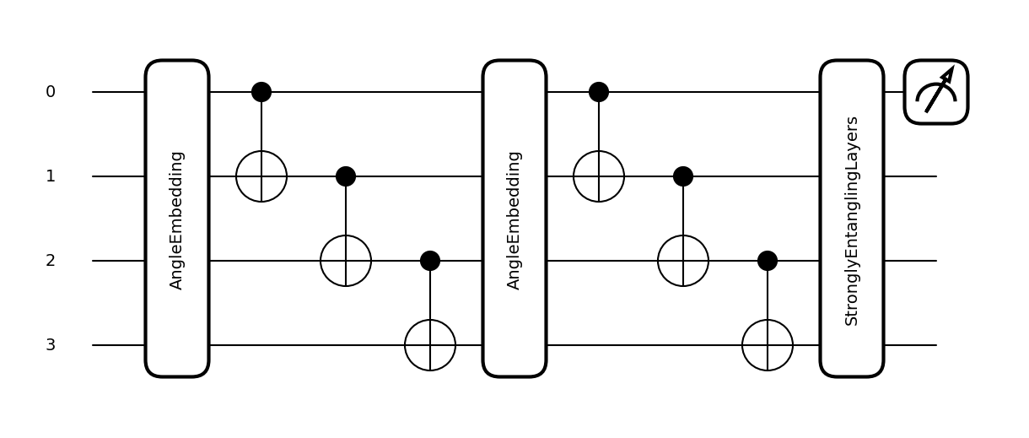
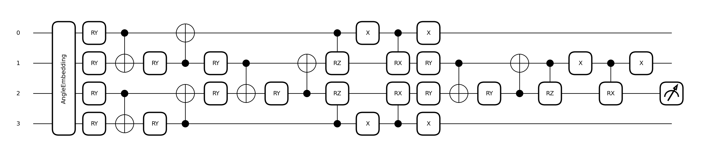
FIGURE 4. Compiled quantum circuits of the study: (a) fidelity-kernel estimation circuit $U_{ϕ}^{†}\left(x_{2}\right)U_{ϕ}\left(x_{1}\right)$ used by QSVM, QKNN, and QSVR; (b) variational QNN (feature map followed by four strongly-entangling layers); (c) single-qubit data re-uploading classifier; (d) QCNN with two convolution stages and two pooling stages reducing four qubits to one.
8) QBOOST: ENSEMBLE SELECTION BY QUANTUM ANNEALING
QBoost [20] builds a strong classifier by selecting a binary-weighted subset of $M$ weak learners $h_{i}\left(x\right)∈\{−1,+1\}$ (here $M=20$ decision stumps trained on bootstrap resamples). Selection is cast as the QUBO problem (5).
minw∈{0,1}M1Mi​wihix−y2+λi​wi, λ=0.05 (5)
The quadratic and linear coefficients are assembled from the weak-learner prediction matrix. The QUBO is solved with the simulated-annealing sampler of the D-Wave Ocean SDK (200 reads); the identical binary quadratic model can be dispatched unchanged to a physical quantum annealer. On our data the optimizer selected 15 of the 20 stumps.
9) QUANTUM-KERNEL SUPPORT VECTOR REGRESSION
For the throughput-regression task, the precomputed quantum Gram matrices of Section III-C2 are supplied to an $ε$-insensitive support vector regressor ($C=10$, $ε=0.1$) trained on the standardized target. The classical comparator is an RBF-kernel SVR with identical hyperparameters.
10) QUANTUM k-MEANS
Unsupervised structure is probed with a $k$-means procedure in which the point-to-centroid distance is the quantum fidelity distance $1−k\left(x,c\right)$ of Section III-C3, evaluated by the kernel circuit; centroid updates remain classical means [37]. With $k=2$ clusters the procedure converged in eight iterations.
11) COMPUTATIONAL COMPLEXITY OF THE MODEL SUITE
Table II summarizes the asymptotic quantum cost of the implemented models in terms of circuit executions, since on hardware each execution is repeated for a constant shot budget (Section IV-C). Kernel methods are quadratic in the training-set size at training time, the dominant cost of this study, but only linear at inference; variational models are linear in both phases but multiply the per-epoch cost by the number of differentiated parameters when gradients are evaluated by parameter shifts on hardware. QBoost is distinctive: its quantum cost is a single anneal of an $M$-variable QUBO, independent of the dataset size, because the data enter only through the classically assembled QUBO coefficients of (5). These complexity classes explain the four orders of magnitude spanned by the time column of Table III.
TABLE II
Asymptotic Quantum Cost of the Implemented Models
Model | Training (circuit executions) | Inference
QSVM / QSVR | $O\left(N^{2}\right)$ Gram construction | $O\left(N\right)$ per sample
QKNN | reuses QSVM Gram | $O\left(N\right)$ per sample
QNN / re-uploading / QCNN | $O\left(ENP\right)$ (parameter shift) | $O\left(1\right)$ per sample
Hybrid quantum-classical | $O\left(ENP_{q}\right)$, $P_{q}$ quantum params | $O\left(1\right)$ per sample
QBoost | $O\left(1\right)$ anneal of $M$-variable QUBO | classical
Quantum $k$-means | $$O\left(IkN\right)$$ | $O\left(k\right)$ per sample
$N$: training samples; $E$: epochs; $P$: trainable circuit parameters; $k$: clusters; $I$: $k$-means iterations; $M$: weak learners.
D. EXPERIMENTAL SETUP AND EVALUATION PROTOCOL
1) PREPROCESSING
The six-dimensional feature vectors are standardized (zero mean, unit variance, fitted on the training split only), reduced by principal component analysis to $n=4$ components, retaining 82.3% of the variance and matching the four-qubit register of the main experiments, and finally min-max scaled to the rotation-angle interval $\left[0,π\right]$ required by the encoding (1). The data are split 75%/25% with class stratification; because fidelity-kernel estimation scales as $O\left(N^{2}\right)$ circuit executions, the training and test sets are subsampled to $N_{tr}=300$ and $N_{te}=100$ points, a regime representative of per-cell RAN learning tasks (Section II).
2) IMPLEMENTATION AND EVALUATION PROTOCOL
All quantum circuits are implemented in PennyLane 0.36 [45] and executed on the default.qubit state-vector simulator; noise experiments use the default.mixed density-matrix simulator; QUBO problems use the D-Wave Ocean samplers. Classical baselines, namely an RBF-kernel SVM, a $k$-NN classifier ($k=5$), a multilayer perceptron with hidden layers (32,16), a 200-tree random forest, and logistic regression, are implemented in scikit-learn [33] with fixed random seeds. Classification is evaluated by accuracy, precision, recall, F1, and ROC-AUC on the held-out test set; regression by mean absolute error (MAE), root mean square error (RMSE), and $R^{2}$; clustering by the adjusted Rand index against the held-out labels. Wall-clock training time is recorded for every model. The complete pipeline, including data cleaning, is released as a single reproducible notebook.
IV. RESULTS
A. COMPARATIVE RESULTS
1) BINARY LINK-QUALITY CLASSIFICATION
Table III reports the held-out performance of the seven quantum classifiers and five classical baselines; Fig. 5 visualizes the four headline metrics, and Fig. 6 shows the confusion matrices of the quantum models.
TABLE III
Held-Out Classification Performance on the Link-Quality Task ($N_{te}=100$)
Model | Accuracy | Precision | Recall | F1 | ROC-AUC | Time (s)
Quantum models
QSVM (quantum kernel) | 0.85 | 0.800 | 0.963 | 0.874 | 0.8873 | 287.0
QKNN (fidelity, $k=5$) | 0.84 | 0.807 | 0.926 | 0.862 | 0.8661 | $$<0.01$$
QNN (variational) | 0.85 | 0.800 | 0.963 | 0.874 | 0.8986 | 497.4
Data re-uploading (1 qubit) | 0.79 | 0.726 | 0.982 | 0.835 | 0.7935 | 360.6
Hybrid quantum-classical | 0.85 | 0.800 | 0.963 | 0.874 | 0.8986 | 414.1
QCNN | 0.85 | 0.800 | 0.963 | 0.874 | 0.8990 | 264.1
QBoost (QUBO annealing) | 0.85 | 0.800 | 0.963 | 0.874 | 0.8468 | 0.10
Classical baselines
SVM-RBF | 0.86 | 0.803 | 0.982 | 0.883 | 0.8523 | $$<0.01$$
KNN ($k=5$) | 0.85 | 0.810 | 0.944 | 0.872 | 0.8543 | $$<0.01$$
MLP (32,16) | 0.85 | 0.800 | 0.963 | 0.874 | 0.8897 | 0.08
Random forest (200 trees) | 0.84 | 0.817 | 0.907 | 0.860 | 0.8808 | 0.11
Logistic regression | 0.86 | 0.803 | 0.982 | 0.883 | 0.8929 | $$<0.01$$
Best value per column in bold. Times are wall-clock on the state-vector simulator and include kernel construction or variational training where applicable; QKNN reuses the QSVM fidelity matrix.
Three observations follow. First, on accuracy the quantum and classical families are at parity: six of the seven quantum models achieve 0.84 to 0.85 against 0.84 to 0.86 for the classical baselines, and with $N_{te}=100$ a one-percentage-point gap corresponds to a single test sample and is not statistically meaningful. Second, the three highest ROC-AUC values of the entire study belong to quantum models, namely QCNN (0.8990), QNN (0.8986), and the hybrid network (0.8986), exceeding the best classical value (logistic regression, 0.8929). Since ROC-AUC measures the quality of the continuous ranking rather than a single thresholded decision, this indicates that the variational quantum models learn a better-calibrated score function on this task, a property directly relevant to RAN use cases in which the score drives a scheduling or admission priority rather than a hard decision. Third, the single-qubit re-uploading classifier is the clear outlier (accuracy 0.79, ROC-AUC 0.7935): one qubit with six re-uploading layers underfits the four-dimensional task, confirming that register width must be commensurate with the data dimensionality (see also Section IV-D).
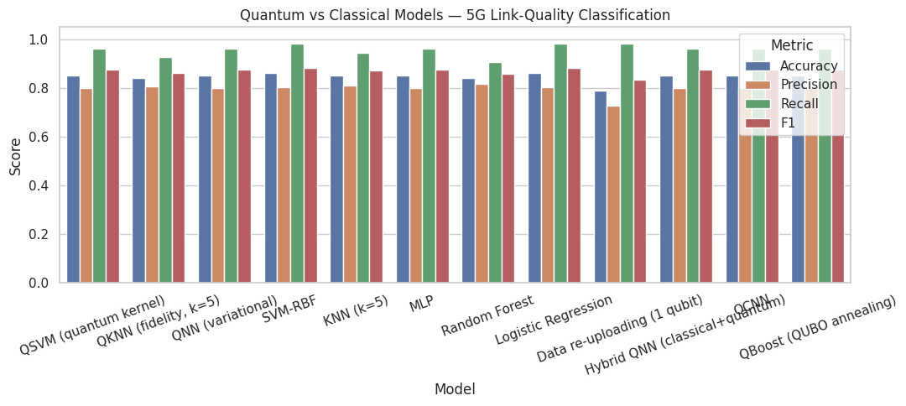
FIGURE 5. Accuracy, precision, recall, and F1 of all twelve models on the held-out test set.
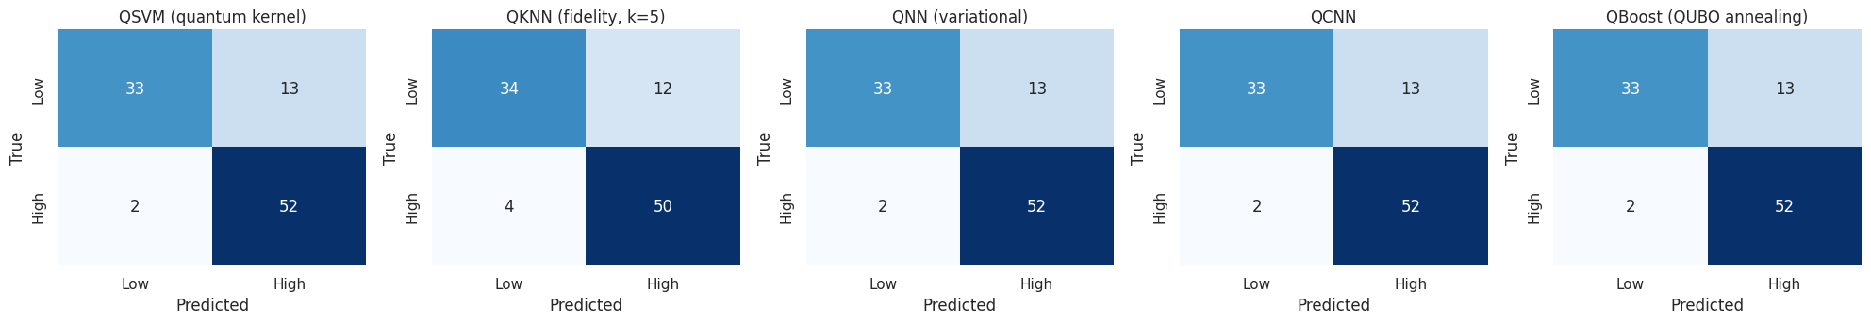
FIGURE 6. Confusion matrices of the quantum classifiers on the held-out test set (low and high downlink-throughput classes).
A closer reading of the confusion matrices (Fig. 6) reveals a consistent asymmetry across the quantum suite: recall of the high-throughput class is very high (0.926 to 0.982) while a minority of low-throughput intervals are misclassified upwards (class-0 recall 0.565 to 0.761 across models). In operational terms the models almost never miss a healthy link but occasionally flag a degraded one as healthy; for admission-control or scheduling applications, in which the cost of over-admitting a degraded link exceeds that of under-admitting a healthy one, the decision threshold on the continuous score should therefore be shifted below zero, a calibration for which the superior ROC-AUC of the variational quantum models provides the most room.
Fig. 7 presents the receiver operating characteristic curves and, complementarily, Fig. 8 the precision-recall curves of all models. The quantum variational family (solid lines) dominates the upper-left region of the ROC plane at low false-positive rates, consistently with its ROC-AUC advantage.
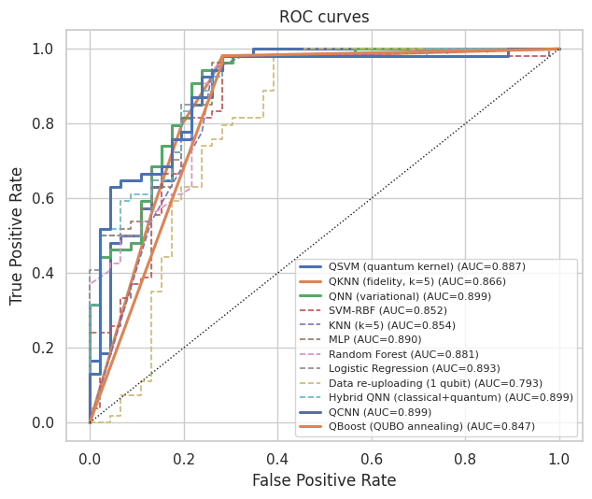
FIGURE 7. Receiver operating characteristic curves of all models; quantum models are drawn with solid thick lines, classical baselines with dashed thin lines.
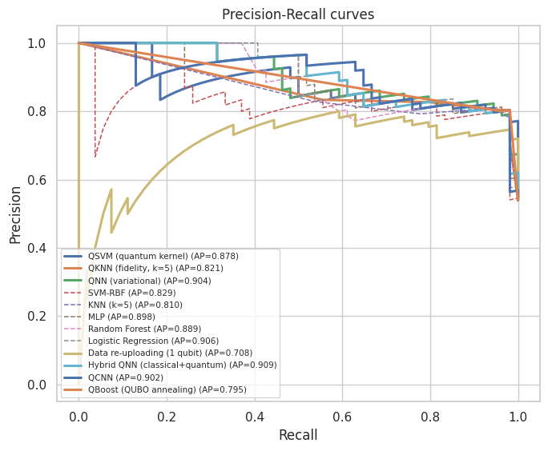
FIGURE 8. Precision-recall curves with average-precision scores.
The wall-clock costs in Table III quantify the present-day price of quantum simulation: variational training requires minutes (264 to 497 s) where classical baselines require milliseconds. Two mitigating observations apply. The QSVM cost is a one-off Gram-matrix construction whose $O\left(N^{2}\right)$ circuit executions parallelize trivially and are reused verbatim by QKNN (inference in $<0.01$ s) and by QSVR (Section IV-A2); and on physical quantum hardware the per-circuit cost is independent of the Hilbert-space dimension, unlike on the simulator (Section IV-D).
2) DOWNLINK THROUGHPUT REGRESSION
Table IV reports the regression results and Fig. 9 the predicted-versus-true scatter. The quantum kernel transfers to the regression setting without retraining any quantum component: QSVR attains $R^{2}=0.762$ against $0.766$ for the classical RBF SVR, that is, statistical parity, with a moderately higher MAE (531.2 versus 398.9) driven by the low-throughput mode, while RMSE is essentially identical (834.8 versus 828.9). The result demonstrates that a single set of quantum Gram matrices supports both discrimination and regression on RAN telemetry.
TABLE IV
Downlink-Throughput Regression on the Held-Out Test Set
Model | MAE | RMSE | $R^{2}$
QSVR (quantum kernel) | 531.16 | 834.85 | 0.7621
SVR-RBF (classical) | 398.91 | 828.93 | 0.7655

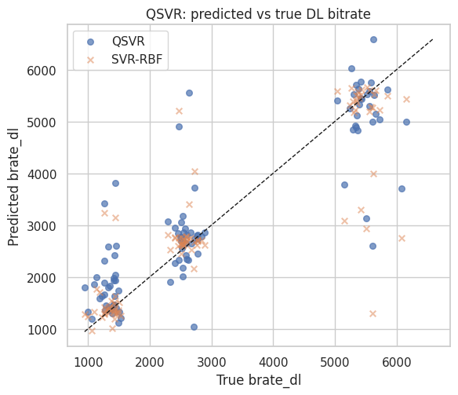
FIGURE 9. Predicted versus true downlink bitrate for the quantum-kernel SVR and the classical RBF SVR.
3) UNSUPERVISED TRAFFIC STRUCTURE
The fidelity-distance quantum $k$-means converged in eight iterations to clusters of 128 and 172 training points and achieved an adjusted Rand index of 0.261 against the held-out throughput labels (Fig. 10). The moderate index indicates that the two throughput regimes are only partially separable without supervision in the four-dimensional encoded space, an expected outcome given that the label-defining feature is deliberately excluded, while the stable convergence demonstrates the viability of quantum fidelity as a clustering metric on real telemetry.
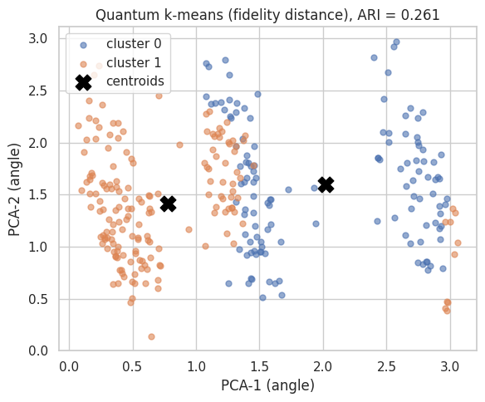
FIGURE 10. Quantum $k$-means clusters ($k=2$, fidelity distance) in the first two encoded principal components; crosses mark the converged centroids.
B. SCIENTIFIC ANALYSIS
This section characterizes the behavior of the quantum models along the axes that determine their practical value: data efficiency, register width, circuit depth, and kernel geometry. NISQ-feasibility axes (noise and shots) are treated in Section IV-C.
1) LEARNING CURVES: THE SMALL-DATA REGIME
Fig. 11 compares QSVM and the classical RBF SVM as the training set grows from 40 to 200 samples. At the smallest size the two are tied (0.80 each); the classical kernel gains an intermediate advantage (0.84 versus 0.76 at $n=120$), and from $n=160$ onwards both converge to 0.84. The quantum kernel thus matches, but on this dataset does not exceed, classical data efficiency, consistent with the kernel-target-alignment analysis of Section IV-B4: whether a quantum kernel is better is dataset-dependent [25], and honest reporting of parity is a necessary datum for the field.
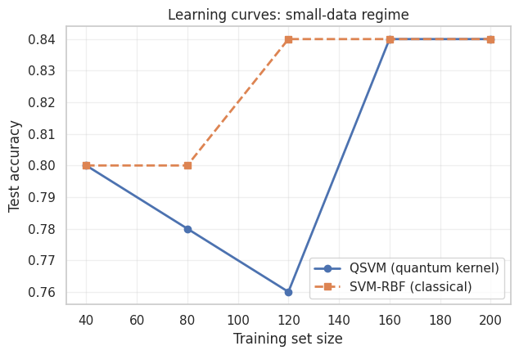
FIGURE 11. Learning curves of QSVM and the classical SVM-RBF.
2) REGISTER WIDTH AND KERNEL CONCENTRATION
Fig. 12 sweeps the number of qubits (and principal components) from 2 to 6 and reports, alongside QSVM accuracy, the variance of the off-diagonal Gram-matrix entries. Accuracy peaks at four qubits (0.80) and declines beyond it, while the kernel variance decays monotonically from 0.105 at two qubits to 0.036 at six, a factor of 2.9 lost over four added qubits. This is a direct empirical observation, on real network telemetry, of the exponential-concentration phenomenon predicted by Thanasilp et al. [29]: as the Hilbert space grows, fidelities between generic encoded states concentrate towards a constant, the Gram matrix flattens, and the downstream SVM loses resolution. Register width is therefore not a free resource to be maximized but a hyperparameter to be matched to the task.
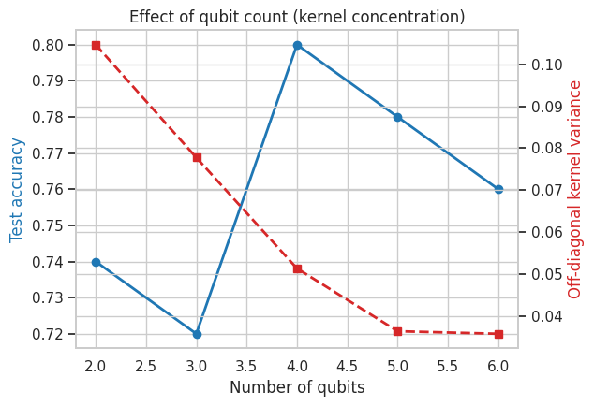
FIGURE 12. QSVM accuracy (left axis) and off-diagonal kernel variance (right axis) versus register width. The variance decay is the empirical signature of kernel concentration.
3) CIRCUIT DEPTH AND TRAINABILITY
Fig. 13 sweeps the number of strongly-entangling layers of the four-qubit QNN from 1 to 8 at a fixed training budget. A single layer is insufficient (accuracy 0.44, final loss 0.894); accuracy rises steeply to 0.72 at two layers and peaks at 0.78 with four layers, beyond which it oscillates (0.74 to 0.76) while training loss continues to decrease (0.503 at $L=4$ down to 0.454 at $L=8$), the classical signature of diminishing generalization returns from added expressivity. At the moderate widths studied here the barren-plateau regime [26] is not yet dominant, but the flat accuracy-depth profile past $L=4$ shows that additional depth buys optimization, not generalization.
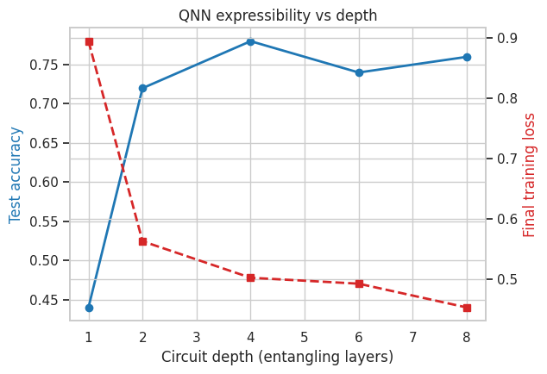
FIGURE 13. QNN test accuracy (left axis) and final training loss (right axis) versus ansatz depth.
4) KERNEL GEOMETRY
Fig. 14 juxtaposes the class-sorted quantum Gram matrix with its classical RBF counterpart and reports the kernel-target alignment [46] given by (6).
$A\left(K,yy^{⊤}\right)=\frac{⟨K,yy^{⊤}⟩_{F}}{∥K∥_{F} ∥yy^{⊤}∥_{F}}$ (6)
The RBF kernel is modestly better aligned (0.1391 versus 0.1078), which explains the absence of a quantum accuracy advantage on this dataset and localizes it at the level of kernel geometry rather than of the downstream solver. Both matrices display visible two-block structure, consistent with the shared 0.85 accuracy plateau of all kernel methods in Table III.
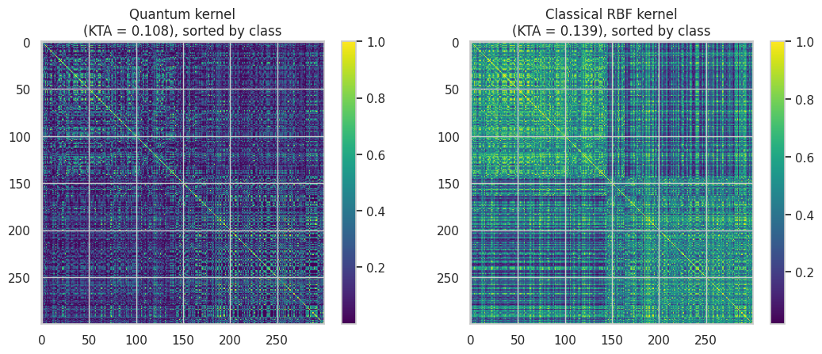
FIGURE 14. Class-sorted Gram matrices of the quantum fidelity kernel (left) and the classical RBF kernel (right), with kernel-target alignment values.
5) DECISION BOUNDARIES
Fig. 15 renders, for a two-qubit and two-component reduction of the task, the decision surface of a trained QNN next to that of the classical RBF SVM. The quantum model carves a smooth, periodic boundary inherited from its trigonometric feature map, in contrast to the localized radial-basis geometry of the SVM; both separate the test points comparably. The visualization makes concrete the distinct inductive bias that quantum encodings impose, namely boundaries built from low-frequency Fourier components of the input angles [39].
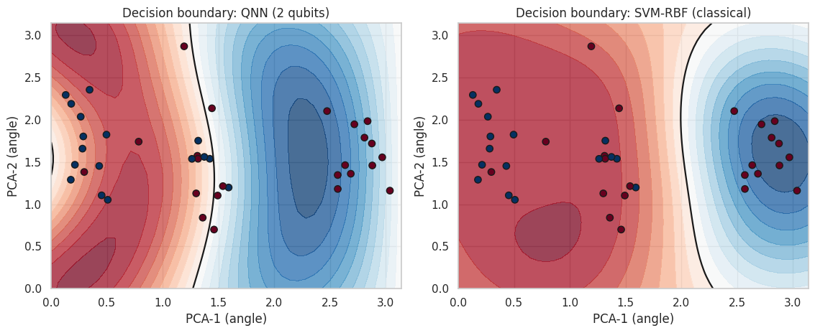
FIGURE 15. Decision surfaces of a two-qubit QNN (left) and the classical RBF SVM (right) in the two-component encoded space; points are held-out test samples.
C. NISQ FEASIBILITY: NOISE AND MEASUREMENT BUDGET
1) ROBUSTNESS TO DEPOLARIZING NOISE
To assess deployability on noisy hardware, the trained four-qubit QNN is re-evaluated on a density-matrix simulator with a depolarizing channel of probability $p$ applied to every qubit after the encoding block and after the variational block. Fig. 16 shows the resulting accuracy. The model is remarkably stable: accuracy is unchanged at 0.85 to 0.86 for all $p≤0.15$, degrades to 0.70 at $p=0.20$, and approaches chance (0.54) only at $p=0.30$. Because the class decision depends only on the sign of $⟨Z_{0}⟩$, and depolarizing noise contracts expectation values towards zero without flipping their sign, moderate noise leaves decisions intact, an architectural robustness argument that favors sign-readout classifiers for NISQ deployment. Current superconducting and trapped-ion processors operate at effective error rates far below the 0.15 tolerance observed here.
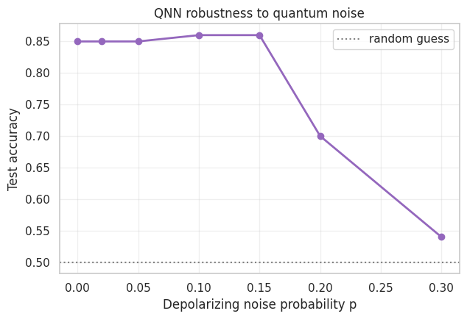
FIGURE 16. Test accuracy of the trained QNN under per-qubit depolarizing noise of probability $p$.
2) MEASUREMENT-SHOT REQUIREMENTS
On hardware, $⟨Z_{0}⟩$ is estimated from a finite number of measurement shots. Fig. 17 reports test accuracy (mean $±$ standard deviation over three repetitions) as the shot budget grows from 8 to 2048, against the analytic (infinite-shot) reference of 0.85. Accuracy already reaches $0.840±0.008$ at 32 shots and matches the analytic value ($0.850±0.008$) at 128 shots, with the residual variance vanishing by 2048 shots. The inference-time measurement budget of the studied workload is therefore modest, of the order of ${10}^{2}$ circuit repetitions per sample, which is negligible for current cloud quantum processors.
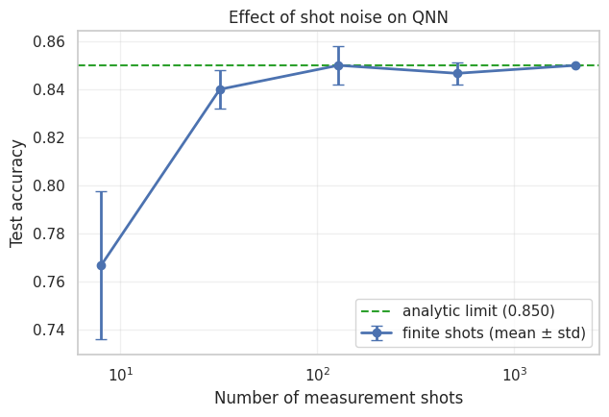
FIGURE 17. QNN test accuracy versus number of measurement shots (mean $±$ standard deviation over three repetitions); the dashed line marks the analytic limit.
D. CIRCUIT SCALABILITY STUDY
The final experiment addresses the central engineering question of NISQ-era QML: what is bought, and what is paid, when the quantum circuit is enlarged? The four-qubit QNN of Section III-C4 is re-instantiated at register widths $n∈\{2,4,5,7,9\}$ with a fixed ansatz depth $L=4$ and a fixed training budget, and five quantities are recorded for each width: the number of trainable parameters, the number of elementary gates and CNOTs after compilation of the circuit to the native gate set, the circuit depth, the wall-clock training and inference times, and the held-out accuracy. Table V collects the measurements; Fig. 18 visualizes them, and Fig. 19 shows the training convergence at every width.
TABLE V
QNN Circuit Scalability: Measured Resources and Performance Versus Register Width
Qubits | $\dim\mathcal{H}$ | Params | Gates | CNOTs | Depth | Train (s) | Infer. (ms) | Accuracy
2 | 4 | 25 | 22 | 10 | 16 | 40.7 | 2.92 | 0.76
4 | 16 | 49 | 46 | 22 | 23 | 82.0 | 5.60 | 0.78
5 | 32 | 61 | 58 | 28 | 25 | 103.1 | 6.92 | 0.76
7 | 128 | 85 | 82 | 40 | 26 | 145.1 | 9.59 | 0.72
9 | 512 | 109 | 106 | 52 | 29 | 188.9 | 12.46 | 0.72
$L=4$ strongly-entangling layers, fixed training budget; gate counts after compilation to elementary rotations and CNOTs.
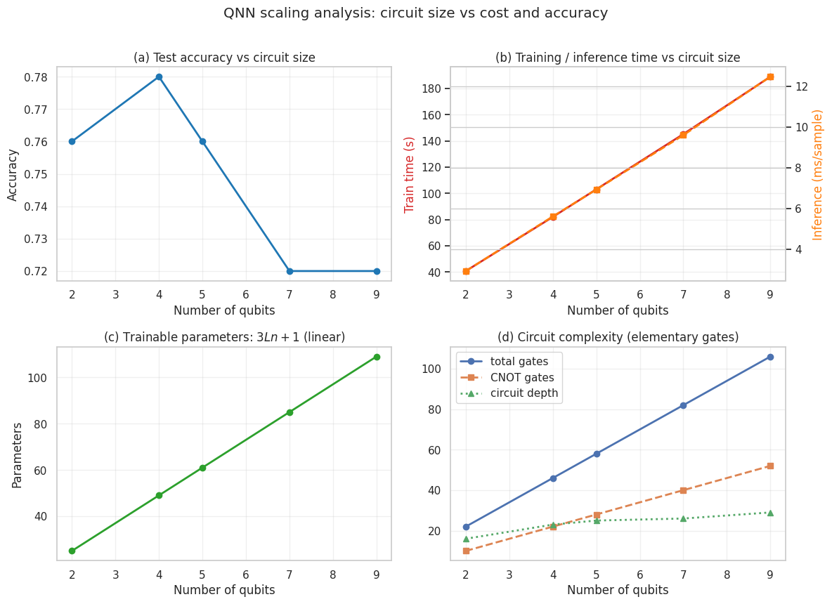
FIGURE 18. QNN scalability versus register width: (a) held-out accuracy; (b) training and per-sample inference time; (c) trainable parameters (linear law $3Ln+1$); (d) compiled circuit complexity (total gates, CNOTs, depth).
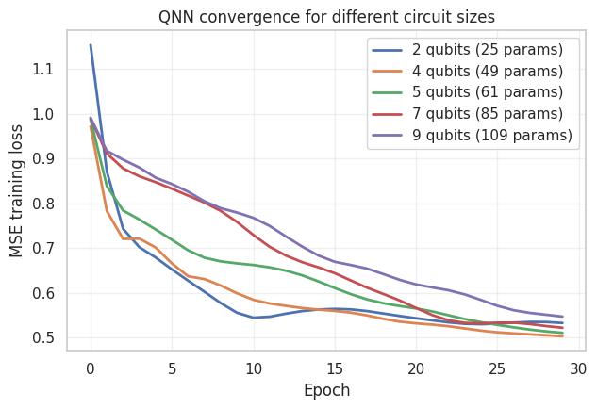
FIGURE 19. Training convergence of the QNN at each register width.
Four scaling laws emerge.
1) Parameters and gates grow linearly
The strongly-entangling ansatz contributes exactly $3Ln$ rotation angles, so the trainable parameter count follows $3Ln+1$: measured values 25, 49, 61, 85, and 109 for $n=2,4,5,7,9$, a 4.4-fold increase across the sweep. Compiled gate counts track the same linear law (22 to 106 elementary gates, 10 to 52 CNOTs; a 4.8-fold increase), and circuit depth grows sub-linearly (16 to 29) because rotations on distinct qubits parallelize.
2) Simulation time grows super-linearly
Training time increases 4.6-fold (40.7 s to 188.9 s) and per-sample inference 4.3-fold (2.92 ms to 12.46 ms) over the sweep. Two multiplicative drivers act simultaneously: the linear growth in differentiated parameters and the exponential growth of the simulated state vector, $dimℋ=2^{n}$ (4 to 512 amplitudes across the sweep). On the widths studied, the parameter term dominates; the exponential term guarantees that classical simulation becomes intractable within tens of qubits, whereas on physical quantum hardware the per-execution cost scales with circuit depth, which grows only from 16 to 29 here. The crossover between these two cost models is precisely the practical opportunity for quantum hardware.
3) Accuracy saturates at the intrinsic dimensionality
Accuracy rises from 0.76 at two qubits to its maximum 0.78 at four qubits, the width at which the register capacity matches the four retained principal components, and then decreases monotonically to 0.72 at seven and nine qubits, even though those models possess up to $2.2×$ more parameters. Three mechanisms jointly explain the decline: (i) beyond six informative features, additional qubits encode zero-padded components and contribute Hilbert-space volume without information; (ii) kernel-level concentration (Section IV-B2) flattens the geometry of the encoded states; and (iii) a larger parameter space at a fixed sample and epoch budget optimizes more slowly, visible in Fig. 19 as the higher final loss of the nine-qubit model (0.547 versus 0.503 at four qubits).
4) Design rule
Taken together, the sweep yields an actionable engineering rule: the register width of a NISQ classifier should be matched to the effective dimensionality of the encoded data, not maximized. Enlarging the circuit purchases parameters, gates, and cost linearly, and simulation cost super-linearly, while returning no accuracy once the intrinsic dimensionality is covered.
V. DEPLOYMENT PATHWAY INTO THE RAN
A concrete deployment architecture follows from the measured costs and feasibility bounds. The $O\left(N^{2}\right)$ quantum-kernel construction and variational training belong in the non-real-time RIC (time scales of minutes to hours), executed on cloud-accessed quantum hardware or simulators, with the resulting support vectors, Gram rows, or circuit parameters cached as model artifacts. Inference then splits by family: QKNN and QSVM scoring reduces to classical inner products against cached kernel rows and runs in microseconds inside a near-real-time xApp, while variational-model inference requires one circuit execution per sample (approximately 128 shots, Section IV) and is presently confined to non-real-time loops by cloud-access latency rather than by computation itself. QBoost occupies the most deployable position of the suite: its quantum cost is a single offline anneal of the QUBO of (5), after which the selected stump ensemble is a pure classical object with sub-millisecond inference. The noise ($p≤0.15$) and shot ($≥128$) tolerances measured in Section IV are comfortably met by current superconducting and trapped-ion processors, and the compiled circuits are shallow (46 elementary gates, depth 23 at four qubits); the principal near-term obstacle is therefore access throughput, not fidelity.
VI. DISCUSSION
A. ANSWERS TO THE RESEARCH QUESTIONS
The results map directly onto the four research questions of Section I. RQ1 (discrimination): on the balanced link-quality task, six of the seven quantum classifiers attain 0.84 to 0.85 accuracy against 0.84 to 0.86 for the tuned classical baselines, that is, statistical parity at $N_{te}=100$, where one percentage point equals one test sample, while the three highest ROC-AUC values of the entire study belong to quantum models (QCNN 0.8990, QNN 0.8986, hybrid 0.8986, versus 0.8929 for the best classical baseline). RQ2 (family profile and transfer): the variational family delivers the best ranking quality; the kernel family delivers the best cost amortization, since one Gram construction serves QSVM, QKNN, and, without retraining any quantum component, the QSVR regressor, which matches classical SVR ($R^{2}$ 0.7621 versus 0.7655); the annealing family (QBoost) matches variational accuracy at three orders of magnitude lower cost, its quantum step being a single QUBO anneal. RQ3 (scalability): growing the QNN from 2 to 9 qubits scales parameters linearly ($3Ln+1$: 25 to 109) and compiled gates linearly (22 to 106), increases training time 4.6-fold, and yields no accuracy return beyond four qubits, the width matching the intrinsic dimensionality of the encoded data, after which accuracy declines from 0.78 to 0.72. RQ4 (NISQ feasibility): the trained QNN retains 0.85 to 0.86 accuracy for all depolarizing probabilities $p≤0.15$, degrades to 0.70 at $p=0.20$, and reaches chance only at $p=0.30$; accuracy matches the analytic limit already at 128 measurement shots ($0.850±0.008$).
B. ANALYSIS OF FINDINGS
Three empirical patterns deserve interpretation. First, the ranking-quality advantage at accuracy parity indicates that the variational quantum models learn a better-calibrated continuous score on this task; for RAN control loops that consume a priority score rather than a hard decision, such as schedulers, admission controllers, and handover engines, ranking quality is the operative metric, which makes this a practically meaningful, if modest, advantage. Second, the learning-curve and kernel-alignment analyses show no quantum data-efficiency advantage: the classical RBF kernel is slightly better aligned with the task (kernel-target alignment 0.1391 versus 0.1078), which localizes the absence of a quantum accuracy advantage at the level of kernel geometry rather than of the downstream solver, consistent with the data-dependence results of Huang et al. [25]. Third, the qubit sweep provides a direct empirical observation, on real network telemetry, of the exponential-concentration phenomenon predicted by Thanasilp et al. [29]: the off-diagonal Gram variance decays 2.9-fold from two to six qubits while accuracy peaks at four. Taken together with the scalability study, the findings yield an actionable design rule: the register width of a NISQ classifier should be matched to the effective dimensionality of the encoded data, not maximized.
C. TRANSFERABILITY AND INTEGRATION
The pipeline is deliberately portable because its organizing principle, namely to encode a small KPI vector into a shallow feature map, reuse one Gram construction across kernel models, and confine training to the non-real-time control loop, is independent of the specific testbed. The same protocol re-instantiates on other srsRAN/Open5GS deployments, on O-RAN-compliant testbeds exposing E2 telemetry, and on adjacent per-cell tasks (handover prediction, anomaly detection, slice-load classification) by re-estimating only the scaler, the principal component basis, and the decision threshold; the model suite, the sweep battery, and the scalability protocol transfer unchanged. Because the QUBO of Section III is solver-agnostic, the QBoost component dispatches unchanged to a physical quantum annealer.
D. LIMITATIONS
Five limitations bound the claims. L1: all quantum executions are simulated; the depolarizing and shot-noise sweeps bound the expected hardware degradation but do not replace device runs. L2: the dataset originates from a single cell under favorable radio conditions (MCS 26 to 28) with stationary UEs; mobility, interference-limited, and multi-cell regimes are untested. L3: the binary label is a median split of the downlink bitrate, one operating point of the link-quality definition, and kernel-method training was subsampled to 300 points for $O\left(N^{2}\right)$ tractability, representative of per-cell learning but not of network-scale training. L4: headline metrics are reported for fixed seeds on $N_{te}=100$ points; several models consequently share identical confusion matrices, a small-sample effect rather than an implementation artifact, since their continuous scores and ROC-AUC values differ, and conclusions are therefore drawn only from metric orderings, monotonic trends across sweeps, and the explicitly repeated shot-noise experiment. L5: wall-clock times compare a quantum simulator against native classical implementations and quantify the present cost of experimentation, not the asymptotic cost of hardware, whose per-execution time is depth-bound rather than Hilbert-space-bound.
E. IDENTIFIED GAPS AND FUTURE WORK
Two evidence gaps remain. G1: no published study, to our knowledge, benchmarks a full QML suite on real RAN telemetry with a joint resource-accuracy scaling law; this article supplies one testbed's worth of such evidence, and replication on other deployments is needed. G2: multi-seed confidence intervals and out-of-time validation remain under-reported in applied QML generally, including here. Future work will accordingly (i) execute the trained models and QUBO instances on physical gate-based and annealing hardware; (ii) extend the dataset to multi-cell, mobility, and interference scenarios with multi-class and time-series targets; (iii) add multi-seed statistics and out-of-time splits; and (iv) integrate the quantum inference path into an O-RAN rApp to measure end-to-end control-loop latency.
VII. CONCLUSION
This article presented, to our knowledge, the first systematic benchmark of quantum machine learning on KPI telemetry captured from an operational open-source 5G standalone testbed. Seven quantum classifiers, a quantum regressor, and a quantum clustering procedure were implemented under a single leakage-free protocol and compared with five classical baselines on 10 000 srsRAN/Open5GS scheduler records. The quantum suite achieved accuracy parity (0.84 to 0.85 versus 0.84 to 0.86) and the three best ROC-AUC scores of the study (QCNN 0.8990; QNN and hybrid 0.8986), while the quantum-kernel regressor matched its classical counterpart ($R^{2}$ 0.762 versus 0.766) at zero additional quantum cost by reusing the classification Gram matrices.
Beyond headline metrics, this article contributed a quantitative characterization of NISQ-era trade-offs on real network data: empirical kernel concentration (off-diagonal variance falling 2.9-fold from two to six qubits), a depth-trainability profile peaking at four entangling layers, noise robustness up to depolarizing probability 0.15, a measurement budget of 128 shots, and a circuit-scalability law showing that parameters and gates grow linearly (25 to 109 and 22 to 106, respectively, from two to nine qubits) and training time 4.6-fold, while accuracy peaks at the register width matching the intrinsic dimensionality of the data and degrades beyond it. The resulting design rule, namely to size the quantum register to the effective dimensionality rather than to the available hardware, together with the released reproducible pipeline, is intended as a calibration point and a starting kit for quantum-assisted radio-network intelligence.
Future work will proceed along three axes: execution of the trained models and QUBO instances on physical gate-based and annealing hardware; extension of the dataset to multi-cell, mobility, and interference scenarios with multi-class and time-series targets; and integration of the quantum inference path into an O-RAN rApp to measure end-to-end control-loop latency.
ACKNOWLEDGMENT
This research was funded by the Committee of Science of the Ministry of Science and Higher Education of the Republic of Kazakhstan (Grant No. BR24993211). The authors also thank the srsRAN and Open5GS open-source communities. The dataset, the complete experimental notebook, and all scripts required to reproduce the results of this article are available from the corresponding author upon reasonable request.
REFERENCES
[1] C. Zhang, P. Patras, and H. Haddadi, "Deep learning in mobile and wireless networking: A survey," IEEE Commun. Surveys Tuts., vol. 21, no. 3, pp. 2224-2287, 3rd Quart. 2019, doi: 10.1109/COMST.2019.2904897.
[2] Y. Sun, M. Peng, Y. Zhou, Y. Huang, and S. Mao, "Application of machine learning in wireless networks: Key techniques and open issues," IEEE Commun. Surveys Tuts., vol. 21, no. 4, pp. 3072-3108, 4th Quart. 2019, doi: 10.1109/COMST.2019.2924243.
[3] M. Polese, L. Bonati, S. D'Oro, S. Basagni, and T. Melodia, "Understanding O-RAN: Architecture, interfaces, algorithms, security, and research challenges," IEEE Commun. Surveys Tuts., vol. 25, no. 2, pp. 1376-1411, 2nd Quart. 2023, doi: 10.1109/COMST.2023.3239220.
[4] L. Bonati, S. D'Oro, M. Polese, S. Basagni, and T. Melodia, "Intelligence and learning in O-RAN for data-driven NextG cellular networks," IEEE Commun. Mag., vol. 59, no. 10, pp. 21-27, Oct. 2021, doi: 10.1109/MCOM.101.2001120.
[5] J. Preskill, "Quantum computing in the NISQ era and beyond," Quantum, vol. 2, p. 79, Aug. 2018, doi: 10.22331/q-2018-08-06-79.
[6] F. Arute et al., "Quantum supremacy using a programmable superconducting processor," Nature, vol. 574, no. 7779, pp. 505-510, Oct. 2019, doi: 10.1038/s41586-019-1666-5.
[7] Y. Kim et al., "Evidence for the utility of quantum computing before fault tolerance," Nature, vol. 618, no. 7965, pp. 500-505, Jun. 2023, doi: 10.1038/s41586-023-06096-3.
[8] J. Biamonte, P. Wittek, N. Pancotti, P. Rebentrost, N. Wiebe, and S. Lloyd, "Quantum machine learning," Nature, vol. 549, no. 7671, pp. 195-202, Sep. 2017, doi: 10.1038/nature23474.
[9] M. Schuld, R. Sweke, and J. J. Meyer, "Effect of data encoding on the expressive power of variational quantum-machine-learning models," Phys. Rev. A, vol. 103, no. 3, Mar. 2021, Art. no. 032430, doi: 10.1103/PhysRevA.103.032430.
[10] R. LaRose and B. Coyle, "Robust data encodings for quantum classifiers," Phys. Rev. A, vol. 102, no. 3, Sep. 2020, Art. no. 032420, doi: 10.1103/PhysRevA.102.032420.
[11] P. Rebentrost, M. Mohseni, and S. Lloyd, "Quantum support vector machine for big data classification," Phys. Rev. Lett., vol. 113, no. 13, Sep. 2014, Art. no. 130503, doi: 10.1103/PhysRevLett.113.130503.
[12] V. Havlicek, A. D. Corcoles, K. Temme, A. W. Harrow, A. Kandala, J. M. Chow, and J. M. Gambetta, "Supervised learning with quantum-enhanced feature spaces," Nature, vol. 567, no. 7747, pp. 209-212, Mar. 2019, doi: 10.1038/s41586-019-0980-2.
[13] M. Schuld and N. Killoran, "Quantum machine learning in feature Hilbert spaces," Phys. Rev. Lett., vol. 122, no. 4, Feb. 2019, Art. no. 040504, doi: 10.1103/PhysRevLett.122.040504.
[14] A. Peruzzo, J. McClean, P. Shadbolt, M.-H. Yung, X.-Q. Zhou, P. J. Love, A. Aspuru-Guzik, and J. L. O'Brien, "A variational eigenvalue solver on a photonic quantum processor," Nature Commun., vol. 5, Jul. 2014, Art. no. 4213, doi: 10.1038/ncomms5213.
[15] K. Mitarai, M. Negoro, M. Kitagawa, and K. Fujii, "Quantum circuit learning," Phys. Rev. A, vol. 98, no. 3, Sep. 2018, Art. no. 032309, doi: 10.1103/PhysRevA.98.032309.
[16] M. Schuld, A. Bocharov, K. M. Svore, and N. Wiebe, "Circuit-centric quantum classifiers," Phys. Rev. A, vol. 101, no. 3, Mar. 2020, Art. no. 032308, doi: 10.1103/PhysRevA.101.032308.
[17] M. Cerezo et al., "Variational quantum algorithms," Nature Rev. Phys., vol. 3, no. 9, pp. 625-644, Aug. 2021, doi: 10.1038/s42254-021-00348-9.
[18] A. Perez-Salinas, A. Cervera-Lierta, E. Gil-Fuster, and J. I. Latorre, "Data re-uploading for a universal quantum classifier," Quantum, vol. 4, p. 226, Feb. 2020, doi: 10.22331/q-2020-02-06-226.
[19] I. Cong, S. Choi, and M. D. Lukin, "Quantum convolutional neural networks," Nature Phys., vol. 15, no. 12, pp. 1273-1278, Dec. 2019, doi: 10.1038/s41567-019-0648-8.
[20] H. Neven, V. S. Denchev, G. Rose, and W. G. Macready, "Training a binary classifier with the quantum adiabatic algorithm," 2008, arXiv:0811.0416.
[21] D. Willsch, M. Willsch, H. De Raedt, and K. Michielsen, "Support vector machines on the D-Wave quantum annealer," Comput. Phys. Commun., vol. 248, Mar. 2020, Art. no. 107006, doi: 10.1016/j.cpc.2019.107006.
[22] A. Mott, J. Job, J.-R. Vlimant, D. Lidar, and M. Spiropulu, "Solving a Higgs optimization problem with quantum annealing for machine learning," Nature, vol. 550, no. 7676, pp. 375-379, Oct. 2017, doi: 10.1038/nature24047.
[23] M. C. Caro, H.-Y. Huang, M. Cerezo, K. Sharma, A. Sornborger, L. Cincio, and P. J. Coles, "Generalization in quantum machine learning from few training data," Nature Commun., vol. 13, Aug. 2022, Art. no. 4919, doi: 10.1038/s41467-022-32550-3.
[24] A. Abbas, D. Sutter, C. Zoufal, A. Lucchi, A. Figalli, and S. Woerner, "The power of quantum neural networks," Nature Comput. Sci., vol. 1, no. 6, pp. 403-409, Jun. 2021, doi: 10.1038/s43588-021-00084-1.
[25] H.-Y. Huang, M. Broughton, M. Mohseni, R. Babbush, S. Boixo, H. Neven, and J. R. McClean, "Power of data in quantum machine learning," Nature Commun., vol. 12, May 2021, Art. no. 2631, doi: 10.1038/s41467-021-22539-9.
[26] J. R. McClean, S. Boixo, V. N. Smelyanskiy, R. Babbush, and H. Neven, "Barren plateaus in quantum neural network training landscapes," Nature Commun., vol. 9, Nov. 2018, Art. no. 4812, doi: 10.1038/s41467-018-07090-4.
[27] Z. Holmes, K. Sharma, M. Cerezo, and P. J. Coles, "Connecting ansatz expressibility to gradient magnitudes and barren plateaus," PRX Quantum, vol. 3, no. 1, Jan. 2022, Art. no. 010313, doi: 10.1103/PRXQuantum.3.010313.
[28] S. Wang, E. Fontana, M. Cerezo, K. Sharma, A. Sone, L. Cincio, and P. J. Coles, "Noise-induced barren plateaus in variational quantum algorithms," Nature Commun., vol. 12, Nov. 2021, Art. no. 6961, doi: 10.1038/s41467-021-27045-6.
[29] S. Thanasilp, S. Wang, M. Cerezo, and Z. Holmes, "Exponential concentration in quantum kernel methods," Nature Commun., vol. 15, Jun. 2024, Art. no. 5200, doi: 10.1038/s41467-024-49287-w.
[30] C. Cortes and V. Vapnik, "Support-vector networks," Mach. Learn., vol. 20, no. 3, pp. 273-297, Sep. 1995, doi: 10.1007/BF00994018.
[31] T. Cover and P. Hart, "Nearest neighbor pattern classification," IEEE Trans. Inf. Theory, vol. 13, no. 1, pp. 21-27, Jan. 1967, doi: 10.1109/TIT.1967.1053964.
[32] L. Breiman, "Random forests," Mach. Learn., vol. 45, no. 1, pp. 5-32, Oct. 2001, doi: 10.1023/A:1010933404324.
[33] F. Pedregosa et al., "Scikit-learn: Machine learning in Python," J. Mach. Learn. Res., vol. 12, pp. 2825-2830, Nov. 2011.
[34] I. Gomez-Miguelez, A. Garcia-Saavedra, P. D. Sutton, P. Serrano, C. Cano, and D. J. Leith, "srsLTE: An open-source platform for LTE evolution and experimentation," in Proc. 10th ACM Int. Workshop Wireless Netw. Testbeds, Exp. Eval., Characterization (WiNTECH), New York, NY, USA, 2016, pp. 25-32, doi: 10.1145/2980159.2980163.
[35] S. Lee and Open5GS Contributors. (2024). Open5GS: Open-Source Implementation of the 5G Core and EPC. [Online]. Available: https://open5gs.org
[36] NR; Physical Layer Procedures for Data, document TS 38.214, 3rd Generation Partnership Project (3GPP), 2023.
[37] S. Lloyd, M. Mohseni, and P. Rebentrost, "Quantum algorithms for supervised and unsupervised machine learning," 2013, arXiv:1307.0411.
[38] K. Bharti et al., "Noisy intermediate-scale quantum algorithms," Rev. Mod. Phys., vol. 94, no. 1, Feb. 2022, Art. no. 015004, doi: 10.1103/RevModPhys.94.015004.
[39] M. Schuld, "Supervised quantum machine learning models are kernel methods," 2021, arXiv:2101.11020.
[40] E. Farhi and H. Neven, "Classification with quantum neural networks on near term processors," 2018, arXiv:1802.06002.
[41] M. Benedetti, E. Lloyd, S. Sack, and M. Fiorentini, "Parameterized quantum circuits as machine learning models," Quantum Sci. Technol., vol. 4, no. 4, Nov. 2019, Art. no. 043001, doi: 10.1088/2058-9565/ab4eb5.
[42] S. Sim, P. D. Johnson, and A. Aspuru-Guzik, "Expressibility and entangling capability of parameterized quantum circuits for hybrid quantum-classical algorithms," Adv. Quantum Technol., vol. 2, no. 12, Dec. 2019, Art. no. 1900070, doi: 10.1002/qute.201900070.
[43] S. J. Nawaz, S. K. Sharma, S. Wyne, M. N. Patwary, and M. Asaduzzaman, "Quantum machine learning for 6G communication networks: State-of-the-art and vision for the future," IEEE Access, vol. 7, pp. 46317-46350, 2019, doi: 10.1109/ACCESS.2019.2909490.
[44] A. S. Cacciapuoti, M. Caleffi, F. Tafuri, F. S. Cataliotti, S. Gherardini, and G. Bianchi, "Quantum Internet: Networking challenges in distributed quantum computing," IEEE Netw., vol. 34, no. 1, pp. 137-143, Jan./Feb. 2020, doi: 10.1109/MNET.001.1900092.
[45] V. Bergholm et al., "PennyLane: Automatic differentiation of hybrid quantum-classical computations," 2018, arXiv:1811.04968.
[46] N. Cristianini, J. Shawe-Taylor, A. Elisseeff, and J. Kandola, "On kernel-target alignment," in Proc. Adv. Neural Inf. Process. Syst. (NIPS), vol. 14, 2001, pp. 367-373.

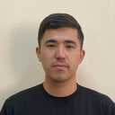
AKSULTAN MUKHANBET received the bachelor’s, M.S., and Ph.D. degrees from Al-Farabi Kazakh National University, Almaty, Kazakhstan. He is currently a Lecturer with the Department of Computer Science, Al-Farabi Kazakh National University. His teaching and research activities cover database design, relational and NoSQL systems, data integrity, machine learning, computer vision, high-performance computing, software engineering, and quantum computing. He has contributed to research on quantum algorithms, hybrid quantum–classical learning, intelligent video surveillance, 5G network analytics, and industrial machine-learning applications. He has authored and coauthored journal articles and conference papers in these areas.
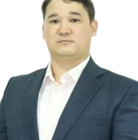
YEDIL NURAKHOV received the bachelor’s degree from the Almaty Institute of Power Engineering and Telecommunications, Almaty, Kazakhstan, in 2009, and the M.S. and Ph.D. degrees in informatics from Al-Farabi Kazakh National University, Almaty, Kazakhstan. He is currently a Senior Lecturer with the Department of Computer Science, Al-Farabi Kazakh National University. His research interests include machine learning for 5G standalone networks, explainable network analytics, intelligent control systems, energy management, HVAC systems, the Internet of Things, and industrial applications of artificial intelligence. He has contributed to research involving srsRAN and Open5GS testbeds, O-RAN, network KPI analysis, thermal control, and data-driven industrial automation.

I, Shonazilov Shona Zhoaraevich, was born on October 29, 1987, in Usharal village, Talas District, Zhambyl Oblast.
From 1994 to 2001, I attended the Abdir Sagyntaev Secondary School in Üsharal village, completing my basic education with outstanding results. From 2001 to 2005, I studied at the Republican Special Physics and Mathematics School-Internat in Almaty and received a secondary education diploma.
In 2005, I enrolled in the “Machine Building” program at the Kazakh National Technical University named after K.I. Satybaldin and graduated in 2009 with a Bachelor's degree.
From September 2012 to June 2014, I pursued a master's degree in Information Technology at the T. Ryskulov Kazakh Economic University, enhancing my professional qualifications in the field of information systems.
To further enhance my education, I completed a second master's degree from 2016 to 2018 at the Faculty of Information Technologies, Al-Farabi Kazakh National University, in the “Analysis of Supercomputing and Cloud Technological Processes” educational program. I defended my master's thesis on “Tools and Methods for Creating Visualizations of Oil Displacement Calculations in Supercomputing Systems” and received my master's degree in 2018.
To continue my scientific research, in 2022 I was admitted to the doctoral program in System Engineering at the Faculty of Information Technologies, Al-Farabi Kazakh National University, and successfully completed the PhD program in 2025.
Currently, I am participating in scientific and innovative projects, conducting research in the fields of information technology, artificial intelligence, and digital twins.


TIMUR IMANKULOV received the bachelor’s degree from Al-Farabi Kazakh National University, Almaty, Kazakhstan, in 2009, the master’s degrees in automation and control and mathematical and computer modeling, and the Ph.D. degree in informatics in 2015. He is currently the Dean of the Faculty of Information Technology and Artificial Intelligence, Al-Farabi Kazakh National University, Almaty, Kazakhstan. He previously held academic and research positions with the Department of Computer Science and received the academic title of Associate Professor in 2022. His research interests include high-performance computing, numerical simulation, machine learning, physics-informed neural networks, quantum computing, digital twins, and computational modeling of complex engineering systems.


BEIMBET DARIBAYEV received the B.S., M.S., and Ph.D. degrees in computer science from Al-Farabi Kazakh National University, Almaty, Kazakhstan, in 2009, 2011, and 2014, respectively. He is currently the Vice-Rector for Academic Affairs and a Member of the Management Board of Shakarim University, Semey, Kazakhstan. His previous positions include Software Engineer, Researcher, Associate Professor, Head of the Computer Science Laboratory, and Head of the Department of Computer Science. He has authored more than 50 scientific publications. His research interests include high-performance computing, numerical modeling, machine learning, quantum computing, and quantum–classical algorithms. He received the Best University Teacher Award in 2019 and the State Scientific Scholarship for Talented Young Scientists in 2022.

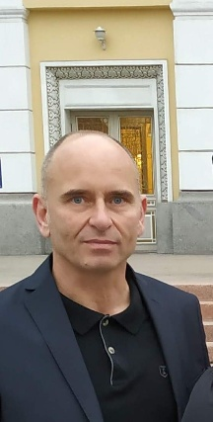
PAULO TRIGO received the degree in applied mathematics from the Faculty of Sciences, University of Lisbon, Lisbon, Portugal, in 1988, the M.S. degree in electrical and computer engineering from Instituto Superior Técnico, University of Lisbon, in 1993, and the Ph.D. degree in informatics engineering and artificial intelligence from the Faculty of Sciences, University of Lisbon, in 2007. He is currently an Adjunct Professor with the Department of Computer Engineering, Instituto Superior de Engenharia de Lisboa, and a Researcher with the University of Lisbon. His research interests include artificial intelligence, multi-agent systems, decision-making, machine learning, reinforcement learning, knowledge representation, ontologies, and geographic information systems.

